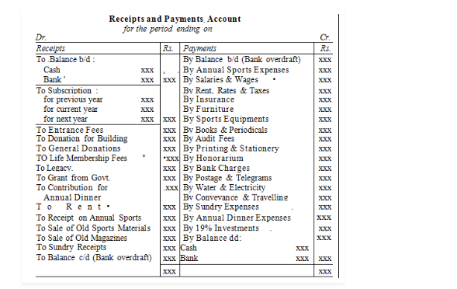Features of Receipt and Payment Account
Below mentioned are the characteristic features of R and P account:
- This Account is a synopsis of cash book
- The cash receipts for the year are documented on its debit side (Dr). And, the payments made in cash for the year are recorded on the credit side (Cr)
- Usually, R and P Account depicts debit balance. If there is overdraft balance, its net balance might be credit
- We document only cash transactions in this account
- We incorporate receipts and payments in cash, they are of revenue and capital nature
- Non-cash items such as outstanding expenses, depreciation, accumulated incomes are shown in this account
- It’s closing balance depicts closing cash in hand and closing cash at the bank
The Income and Expenditure Account is a summary of all items of incomes and expenses which relate to the ongoing accounting year. It is prepared with the objective of finding out the surplus or deficit arising out of current incomes over current expenses. It is quite similar to the Trading and Profit and Loss Account of a trading concern and is prepared in an exact manner.
Income and Expenditure Account is prepared on an accrual basis. All incomes and expenses relating to the accounting year, whether they are actually received and paid or not, are taken into consideration. Expenditure is recorded on the debit side and income is recorded on the credit side. A distinction is made between capital and revenue items and only revenue items are included in this account.
Income and Expenditure Account is a nominal account. Therefore, the rule of nominal account (debit all expenses and losses and credit all incomes and gains) is followed while preparing it. While preparing the account, only items of revenue nature are recorded and all items of capital nature are ignored. For example, the profit earned or loss suffered on the sale of an asset will be recorded in it but the amount received from the sale of an asset will not be recorded in it.
The closing balance of this account shows a surplus or deficit for the year. If the credit side exceeds the debit side, there is surplus. On the other hand, if the debit side exceeds the credit side, there is a deficit. The surplus is added to the Capital Fund while the deficit is deducted from the Capital Fund.

Preparation of Income and Expenditure Account
For preparing an income and expenditure account, follow the steps as listed below.
- Include all items of revenue receipts and expenses, on the respective side of the account.
- Ensure that no items of capital incomes and expenses are included in this account.
- Also, adjustment for amounts prepaid and outstanding, with respect to each item will have to be made.
- Further, items included in receipts and payment account, depreciation, provisions, and profit or loss on sale of assets will have to be included in this account.
- Finally, after putting down all items of revenue and expenses, you’ll get a balance. The resulting balance will then reveal the surplus or deficit for the period.
